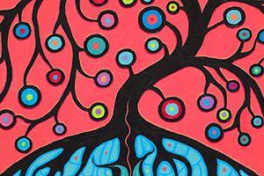
THE JOURNEY TOGETHER
Our traditional teachings speak to us about our connection to each other as we move throughout creation, Mino Bimawdiziwin. In order for true reconciliation to happen in this time, we must acknowledge and honour this extended family relationship and our collective commitment to doing things in the best way, thinking seven generations into the future. In taking this walk together we have the knowledge to build a solid foundation for a partnership based on the highest values of respect and kindness. We must fulfill our mutual responsibilities in this spirit of unity. Elder and advisor Shelley Charles, Chippewas of Georgina Island First Nation
All Canadians must now demonstrate the same level of courage and determination, as we commit to an ongoing process of reconciliation. By establishing a new and respectful relationship between Aboriginal and non-Aboriginal Canadians, we will restore what must be restored, repair what must be repaired, and return what must be returned. Excerpt from ‘What We Have Learned: Principles of Truth and Reconciliation,’ 2015
https://files.ontario.ca/trc_report_web_mar17_en_1.pdf

